**3.1.1a Describe and Justify the Problem**

- My NEA Coursework for Computer Science is based on a popular old generation game called Space Invaders. A game where a single spaceship moves through space like setting environment with waves of enemies that approach with each level, although there are numerous renditions to this game the general idea is that the Player’s spaceship and enemy spaceships shoot projectiles at each other, in order to take out the other. The game typically features a single Player spaceship and from upwards of 5 adversaries dependent on the level and its complexity. The original playable in arcades exclusively was launched in 1978 looked something along the lines of:

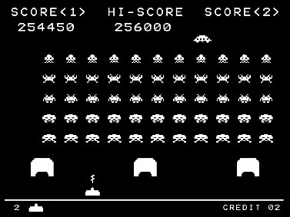Whilst my game follows the same general idea, there are a few key differences. These changes are the Justification of my Problem. For example, the game was originally created to be a single player game, this meant that only one person could experience this at a time, this greatly negates the aspect of playability and enjoying the game. Another large issue is that with the advancement of technology, gaming as a whole has evolved so rapidly that it can be argued that the originality and dexterity of old generations games such as Space Invaders has been long lost. Current issues of the game look like so:

Almost unrecognizable from the 1978 rendition of the same. My solution attempts to bring back the integrity of Space Invaders with a couple of adjustments and elements of the modern gaming world to create a universally enjoyable experience.